Complexity of Algorithms
The time and space implemented by Algorithm X are the two main factors that determine the efficiency of X.
- Time Factor − The time is calculated or measured by counting the number of key operations such as comparisons in the sorting algorithm.
- Space Factor − The space is calculated or measured by counting the maximum memory space required by the algorithm.
The complexity of an algorithm f(N) provides the running time and/or storage space needed by the algorithm with respect to N as the size of input data.
- Space Complexity
The space complexity of an algorithm represents the amount of memory space needed by the algorithm in its life cycle.
- Time Complexity
The Time Complexity of an algorithm is the representation of the amount of time required by the algorithm to execute to completion.
Asymptotic Analysis:
The efficiency of an algorithm depends on the amount of time, storage, and other resources required to execute the algorithm. The efficiency is measured with the help of asymptotic notations. The study of the change in performance of the algorithm with the change in the order of the input size is defined as asymptotic analysis.
Asymptotic Notations
Asymptotic notations are the mathematical notations used to describe the running time of an algorithm when the input tends towards a particular value or a limiting value.
There are mainly three asymptotic notations:
- Big-O Notation (O-notation)
Big-O notation represents the upper bound of the running time of an algorithm. Thus, it gives the worst-case complexity of an algorithm.
- Omega Notation (Ω-notation)
Omega notation represents the lower bound of the running time of an algorithm. Thus, it provides the best-case complexity of an algorithm.
- Theta Notation (Θ-notation)
Theta notation encloses the function from above and below. Since it represents the upper and the lower bound of the running time of an algorithm, it is used for analyzing the average-case complexity of an algorithm.

Range of Values
O(n)
Average: O(1) or Theta(1)
O(1) best or Omega(1)
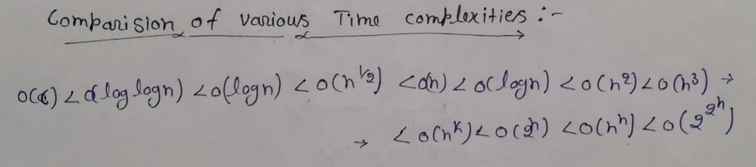
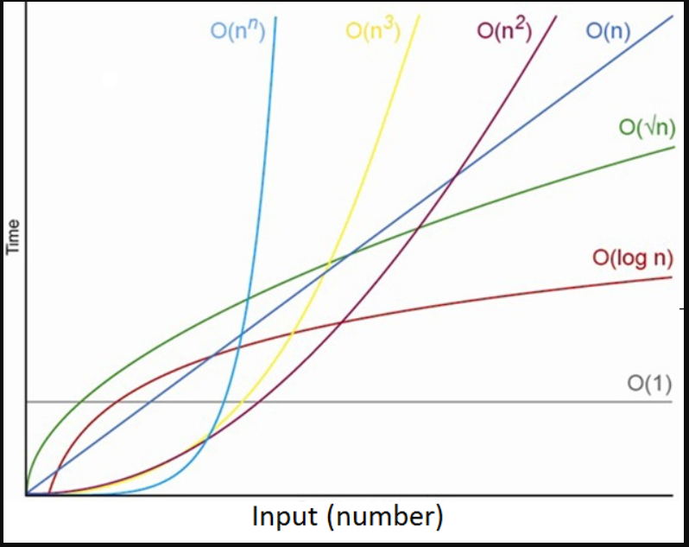
Graphical representation

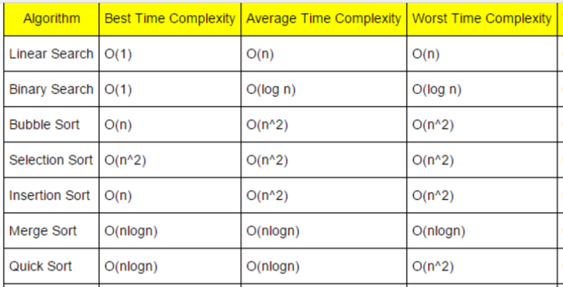-

Searching and Sorting Algorithms
Searching Algorithms
- Linear Search
The linear search algorithm searches all elements in the array sequentially. Its best execution time is one, whereas the worst execution time is n, where n is the total number of items in the search array.
Time Complexity
- Best-case complexity = O(1) occurs when the search element is present at the first element in the search array.
- Worst-case complexity = O(n) occurs when the search element is not present in the set of elements or array.
- Average complexity = O(n) is referred to when the element is present somewhere in the search array.
Code:
class LinearSearch {
// This function returns index of element x in arr[]
static int search(int arr[], int n, int x)
{
for (int i = 0; i < n; i++) {
// Return the index of the element if the element
// is found
if (arr[i] == x)
return i;
}

// return -1 if the element is not found
return -1;
}

public static void main(String[] args)
{
int[] arr = { 3, 4, 1, 7, 5 };
int n = arr.length;

int x = 40;

int index = search(arr, n, x);
if (index == -1)
System.out.println("Element is not present in the array");
else
System.out.println("Element found at position " + index);
}
}
- Binary Search
This algorithm finds specific items by comparing the middlemost items in the data collection. When a match occurs, it returns the index of the item. When the middle item is greater than the item, it searches for a central item of the left sub-array. In contrast, if the middle item is smaller than the search item, it explores the middle of the item in the right sub-array. It continues searching for an item until it finds it or until the sub-arrays size becomes zero.
Binary search needs sorted order of items. It is faster than a linear search algorithm. It works on the divide and conquers principle.
- Run-time complexity = O(log n)
Code
class BinarySearchExample{
public static void binarySearch(int arr[], int first, int last, int key){
int mid = (first + last)/2;
while( first <= last ){
if ( arr[mid] < key ){
first = mid + 1;
}
else if ( arr[mid] == key ){
System.out.println("Element is found at index: " + mid);
break;
}else{
last = mid - 1;
}
mid = (first + last)/2;
}
if ( first > last ){
System.out.println("Element is not found!");
}
}
public static void main(String args[]){
int arr[] = {10,20,30,40,50};
int key = 50;
int last=arr.length-1;
binarySearch(arr,0,last,key);
}
}

Code (Using Recursion)
class BinarySearch {
// Returns index of x if it is present in arr[l..
// r], else return -1
int binarySearch(int arr[], int l, int r, int x)
{
if (r >= l) {
int mid = l + (r ) / 2;
// If the element is present at the middle itself
if (arr[mid] == x)
return mid;
// If element is smaller than mid, then it can only be present in left subarray
if (arr[mid] > x)
return binarySearch(arr, l, mid - 1, x);

// Else the element can only be present
// in right subarray
return binarySearch(arr, mid + 1, r, x);
}

// We reach here when element is not present
// in array
return -1;
}

// Driver method to test above
public static void main(String args[])
{
BinarySearch ob = new BinarySearch();
int arr[] = { 2, 3, 4, 10, 40 };
int n = arr.length;
int x = 10;
int result = ob.binarySearch(arr, 0, n - 1, x);
if (result == -1)
System.out.println("Element not present");
else
System.out.println("Element found at index "
+ result); }}
Sorting
- Bubble sort
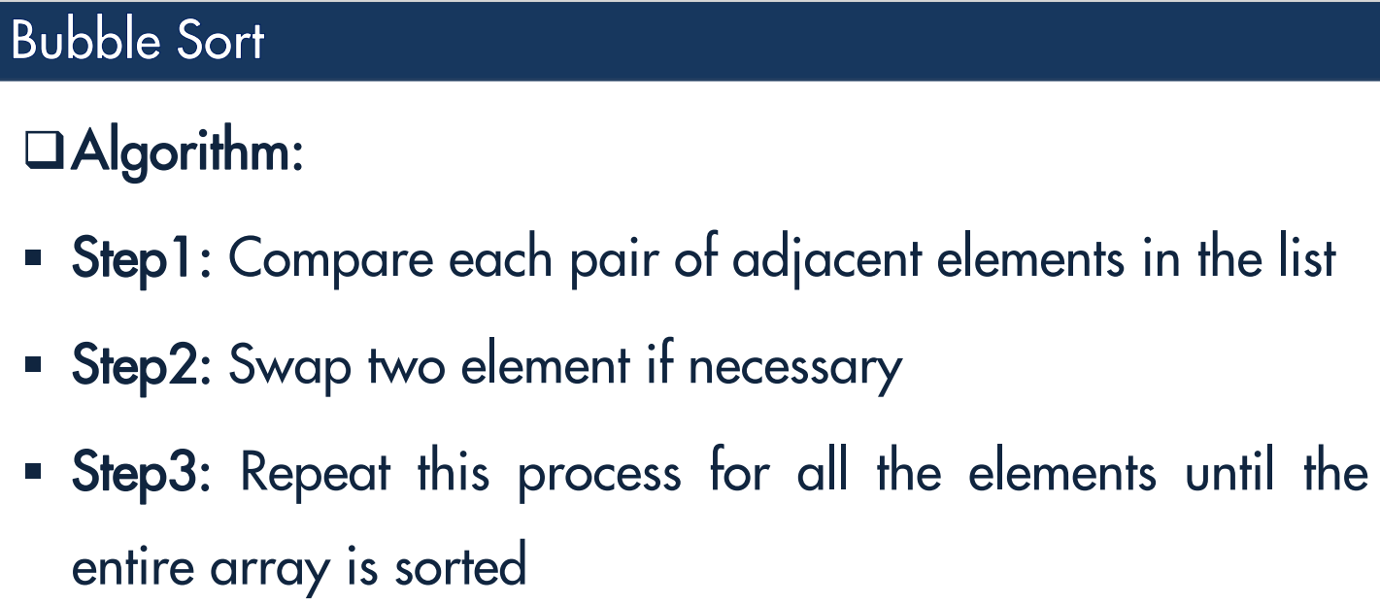
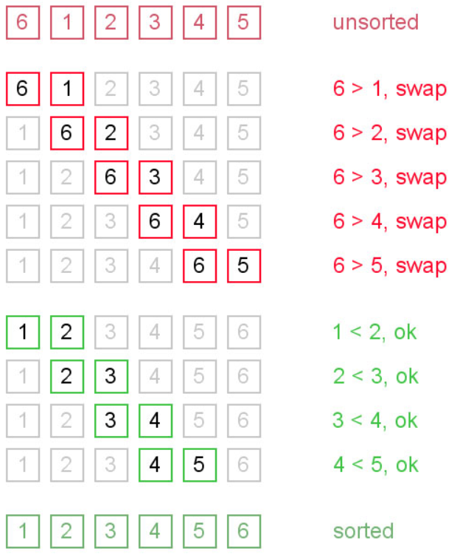
public static void bubbleSort(int[] a)
{
int outer, inner;
for (outer = a.length - 1; outer > 0; outer--) { // counting down
for (inner = 0; inner < outer; inner++) { // bubbling up
if (a[inner] > a[inner + 1]) { // if out of order...
int temp = a[inner]; // ...then swap
a[inner] = a[inner + 1];
a[inner + 1] = temp; } }}
Selection sort
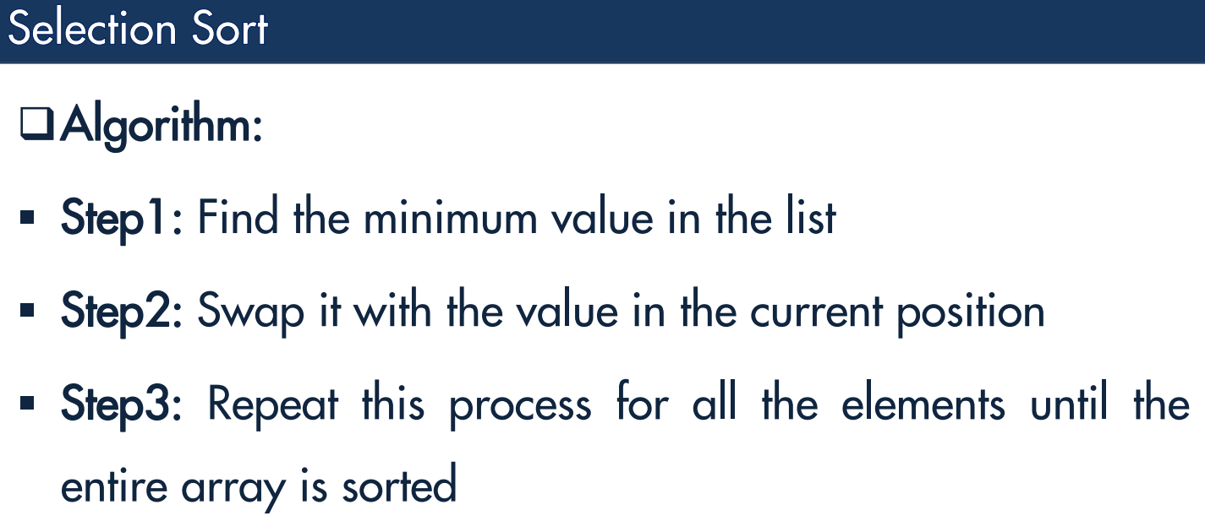
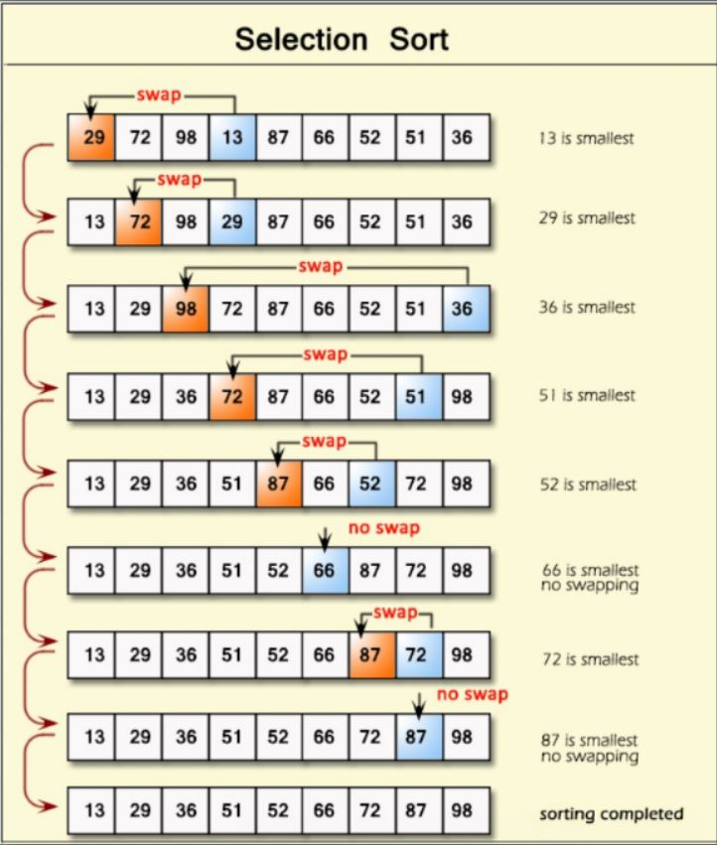
public class SelectionSortExample {
public static void selectionSort(int[] arr){
for (int i = 0; i < arr.length - 1; i++)
{
int index = i;
for (int j = i + 1; j < arr.length; j++){
if (arr[j] < arr[index]){
index = j;//searching for lowest index
} }
int smallerNumber = arr[index];
arr[index] = arr[i];
arr[i] = smallerNumber;
}
}
- Insertion sort
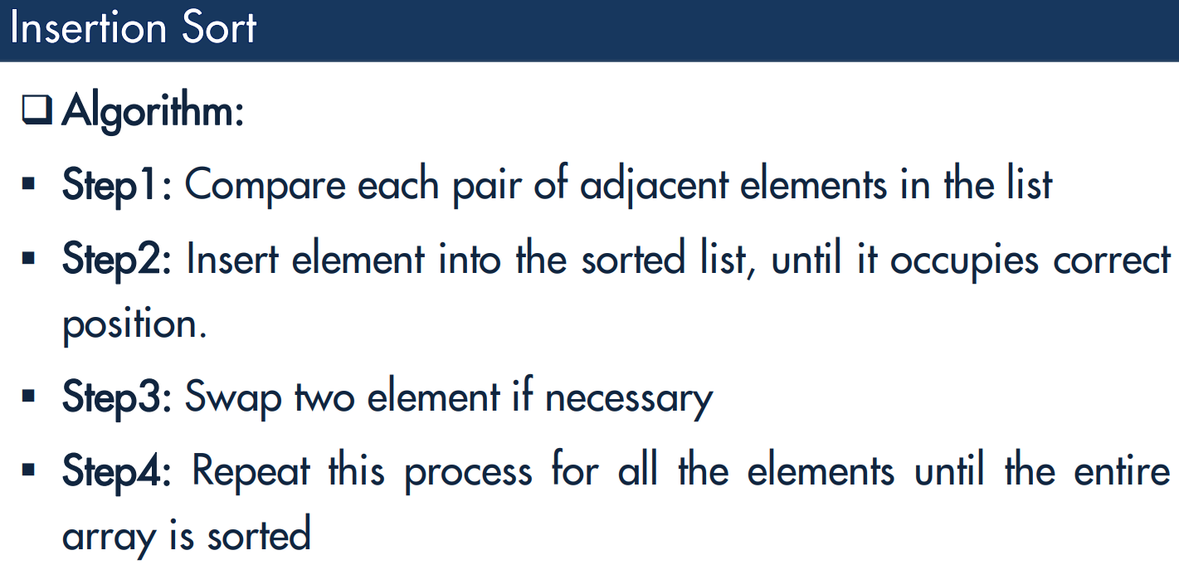
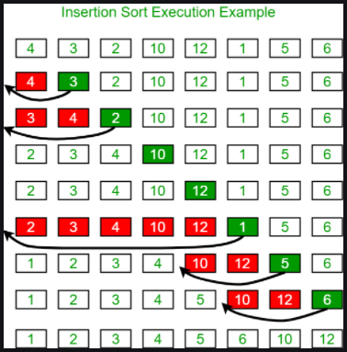
class InsertionSort {
/*Function to sort array using insertion sort*/
void sort(int arr[])
{
int n = arr.length;
for (int i = 1; i < n; ++i) {
int key = arr[i];
int j = i - 1;

/* Move elements of arr[0..i-1], that are
greater than key, to one position ahead
of their current position */
while (j >= 0 && arr[j] > key) {
arr[j + 1] = arr[j];
j = j - 1;}
arr[j + 1] = key;
} }

